Ideation Phase
Define the Problem Statements

Date | 31 January 2026
Team ID | SWTID-2026-1718
Project Name | Streamlining ticket assignment for efficient support operations
Maximum Marks | 2 Marks

Customer Problem Statement Template:
At ABC Corporation, customers frequently experience delays in issue resolution after submitting support tickets. They often face frustration due to tickets being assigned to the wrong teams, leading to longer wait times and repeated follow-ups. Customers expect quick, accurate, and transparent support that resolves their problems efficiently. However, the current manual routing process lacks consistency and speed, resulting in dissatisfaction and reduced trust in the support system. Customers need a streamlined, automated ticket assignment experience that ensures their issues are directed to the right experts without unnecessary delays. By implementing an automated ticket routing system in ServiceNow, ABC Corporation can create a smoother, faster, and more reliable support experience that aligns with customer expectations and builds long-term satisfaction
Section Details
I am A customer of ABC Corporation who relies on prompt and accurate
technical support for resolving issues related to platform access, user accounts, and certifications.
I'm trying to Get my technical issues resolved quickly by the correct support team
without unnecessary delays or repeated ticket transfers.
But My tickets are often assigned to the wrong teams, causing long waiting
times, multiple follow-ups, and delayed problem resolution.
Because The current ticket assignment process is manual, lacks automation, and
depends on human decision-making, leading to inefficiencies
Which makes me feel Frustrated, undervalued, and dissatisfied as I spend too much time waiting for help and lose confidence in the company’s support system.

.

Example:
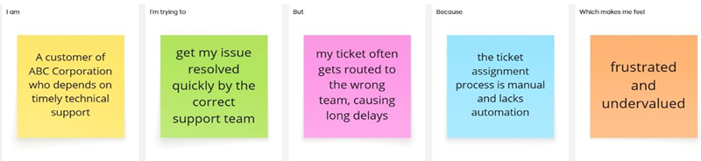
Problem Statement (PS) | I am (Customer) | I’m trying to | But | Because | Which makes me feel
PS-1 | A Support Agent | Resolve customer tickets quickly and efficiently | Tickets are often routed to the wrong team | The ticket assignment process is manual and lacks automation | Overwhelmed and delayed in responding to customers
PS-2 | A Customer | Get my issue resolved by the right team without delay | My ticket keeps getting transferre d between departme nts | There is no automated system to categorize and assign tickets correctly | Frustrated and undervalued

